* Task 1: Implement Management Groups
* Task 2: Create custom RBAC roles
* Task 3: Assign RBAC roles

Task 1: Implement Management Groups

1. Sign in to the [**Azure portal**](http://portal.azure.com/).
2. Search for and select **Management groups** to navigate to the **Management groups** blade.
3. Review the messages at the top of the **Management groups** blade. If you are seeing the message stating **You are registered as a directory admin but do not have the necessary permissions to access the root management group**, perfom the following sequence of steps:

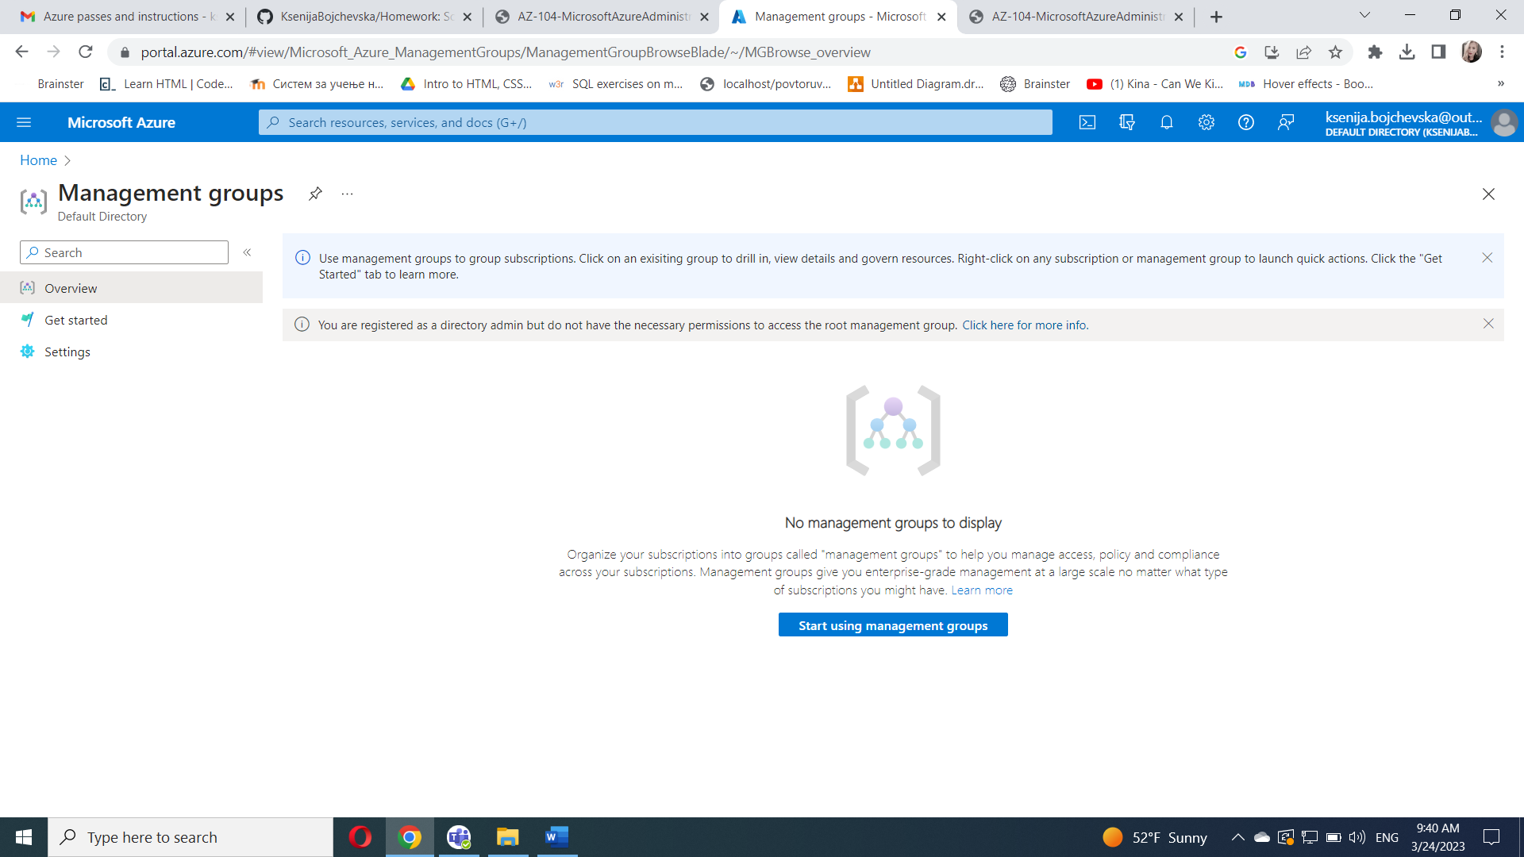

In the Azure portal, search for and select **Azure Active Directory**.

On the blade displaying properties of your Azure Active Directory tenant, in the vertical menu on the left side, in the **Manage** section, select **Properties**.

On the **Properties** blade of your your Azure Active Directory tenant, in the **Access management for Azure resources** section, select **Yes** and then select **Save**.

Navigate back to the **Management groups** blade, and select **Refresh**.

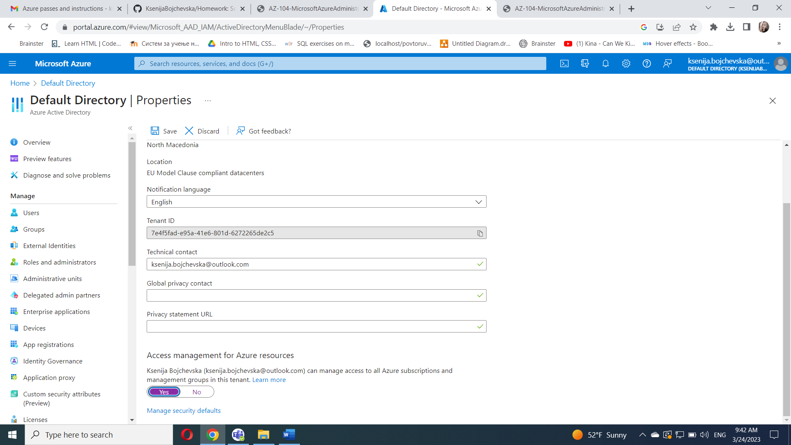

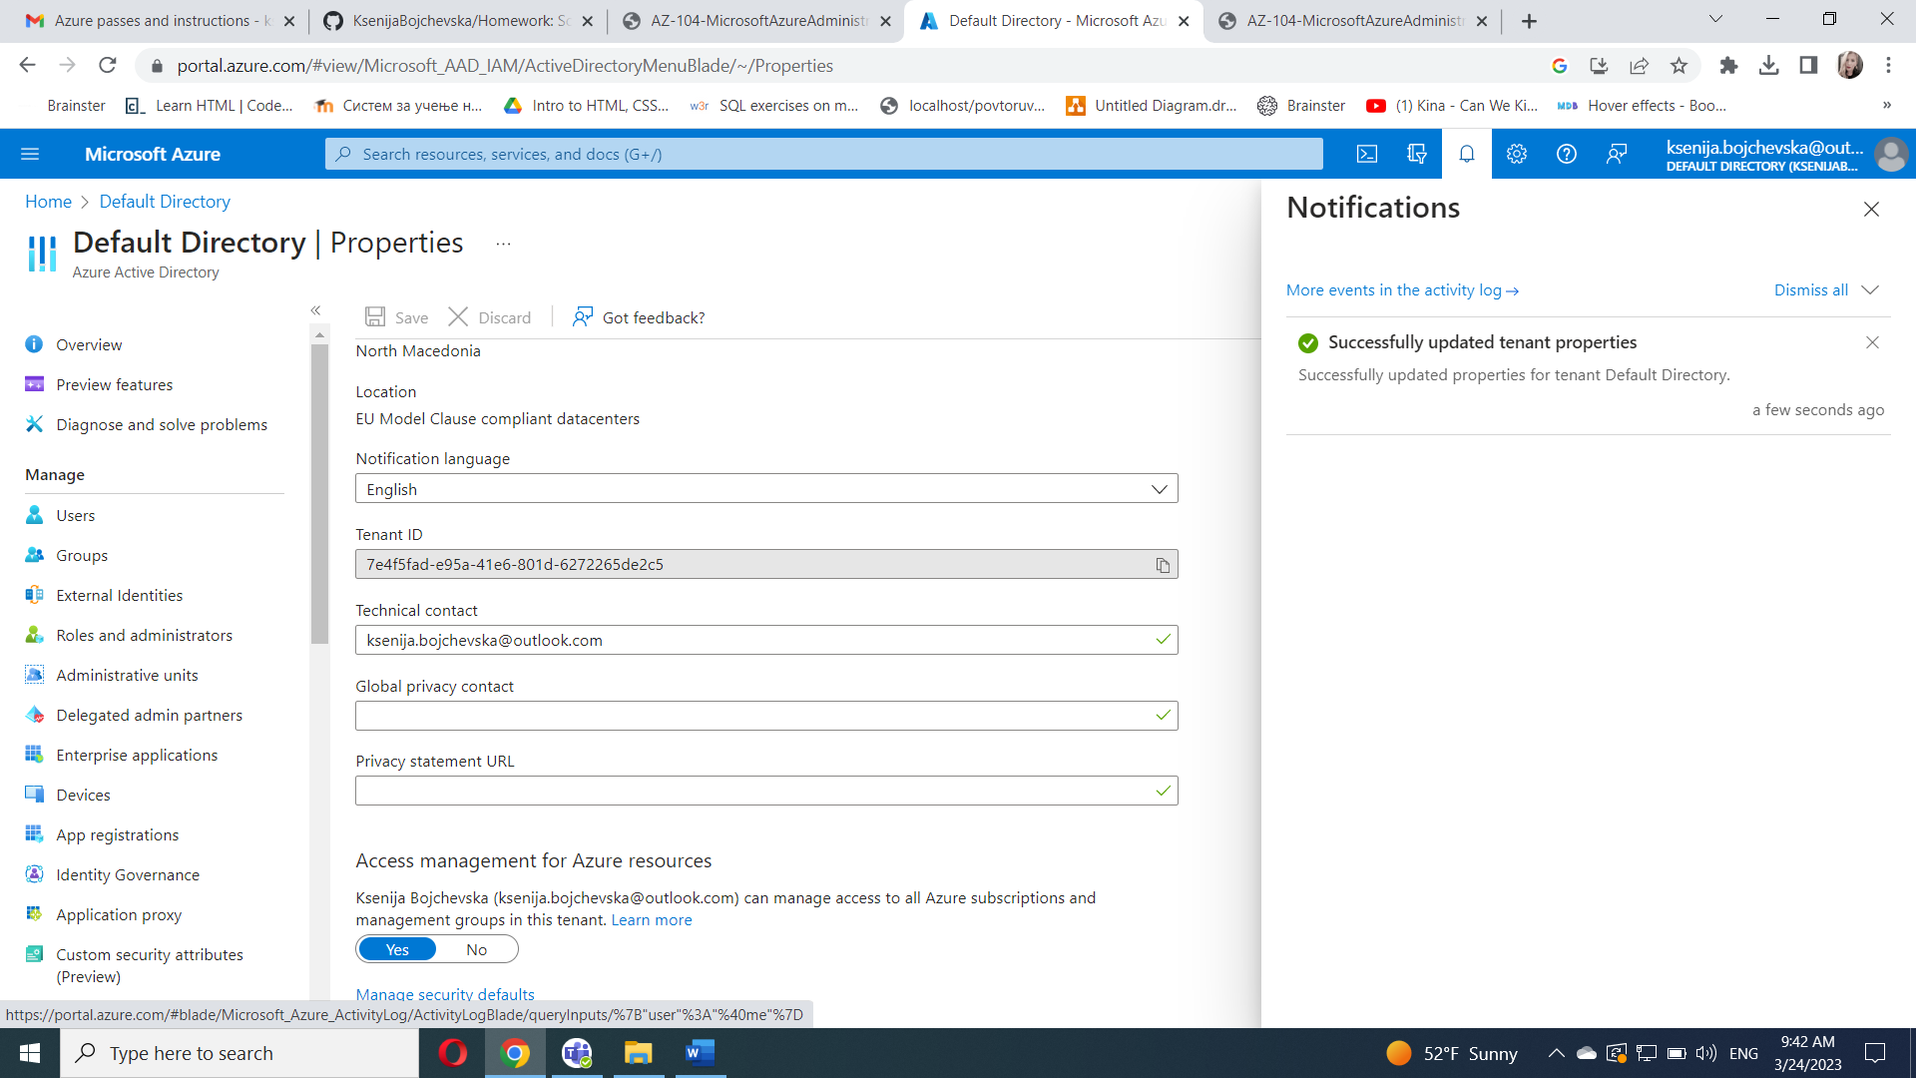

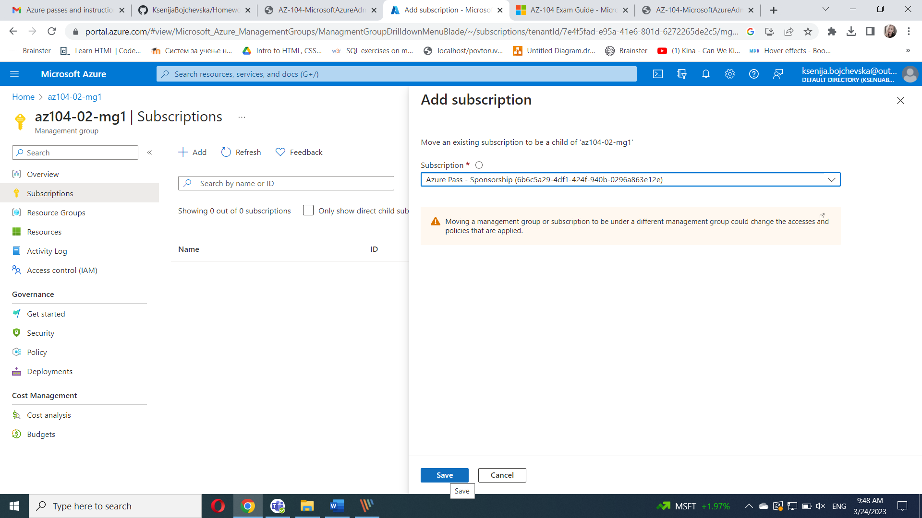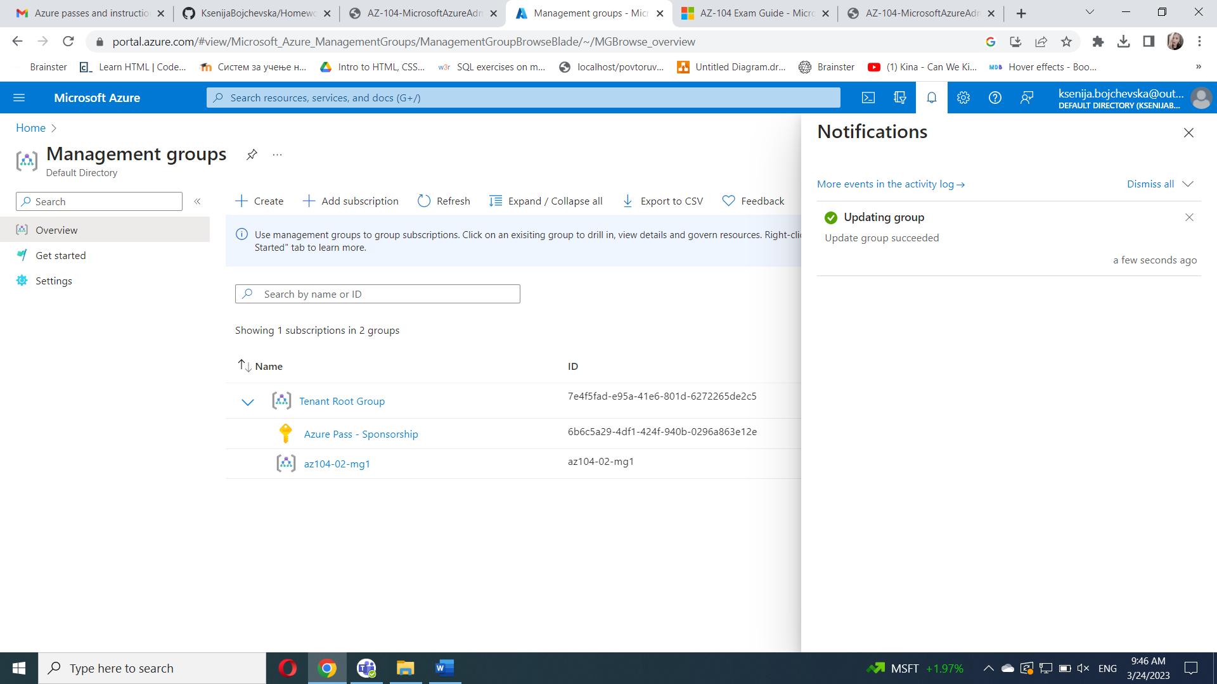

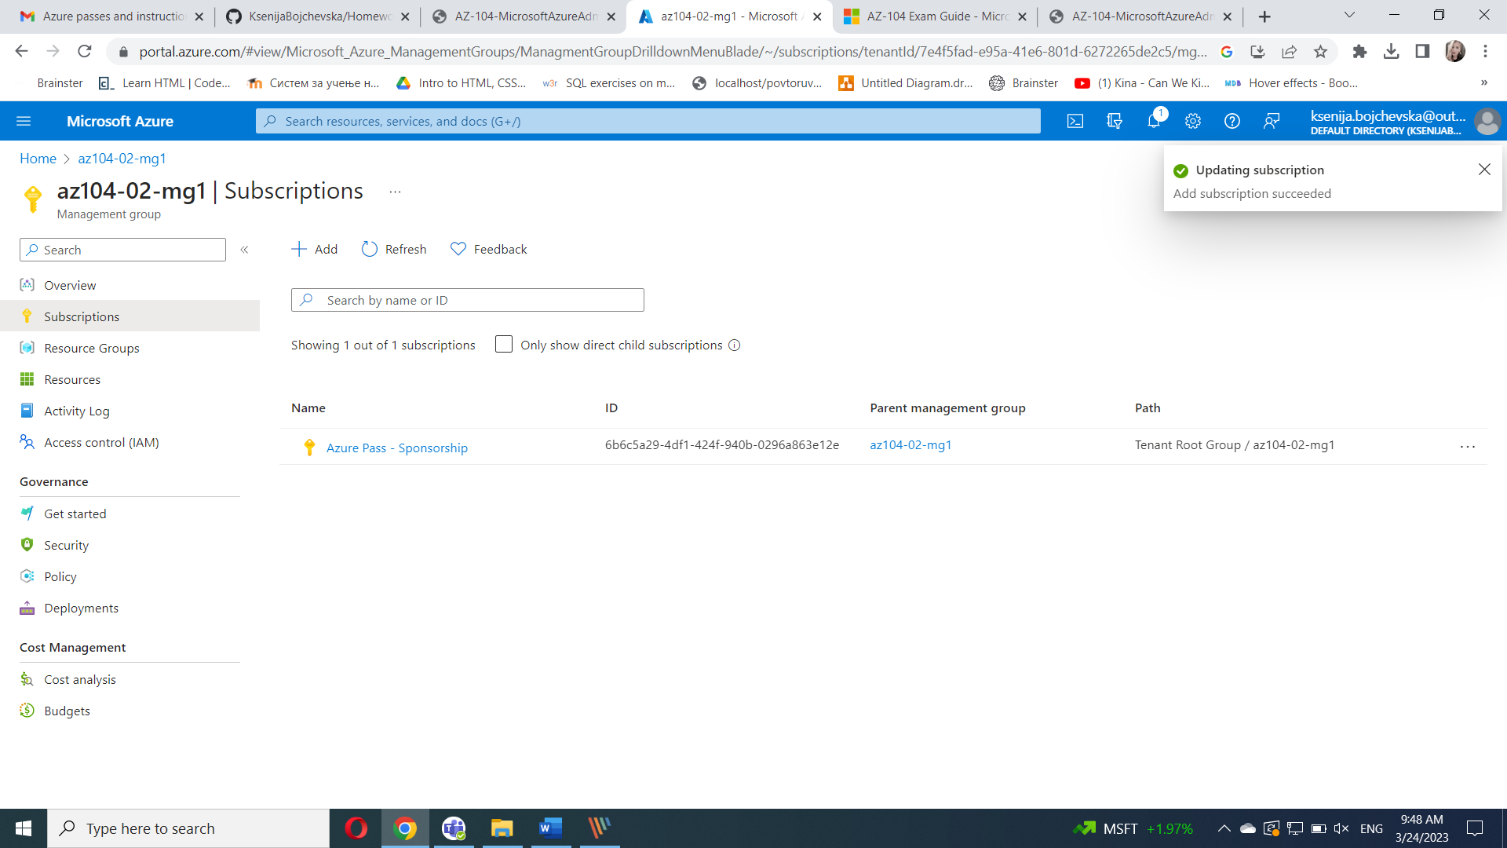

#### Task 2: Create custom RBAC roles

In this task, you will create a definition of a custom RBAC role.

From the lab computer, open the file **\Allfiles\Labs\02\az104-02a-customRoleDefinition.json** in Notepad and review its content:

Replace the SUBSCRIPTION_ID placeholder in the JSON file with the subscription ID you copied into Clipboard and save the change.

In the Azure portal, open **Cloud Shell** pane by clicking on the toolbar icon directly to the right of the search textbox.

If prompted to select either **Bash** or **PowerShell**, select **PowerShell**.

In the toolbar of the Cloud Shell pane, click the **Upload/Download files** icon, in the drop-down menu click **Upload**, and upload the file **\Allfiles\Labs\02\az104-02a-customRoleDefinition.json** into the Cloud Shell home directory.

From the Cloud Shell pane, run the following to create the custom role definition:

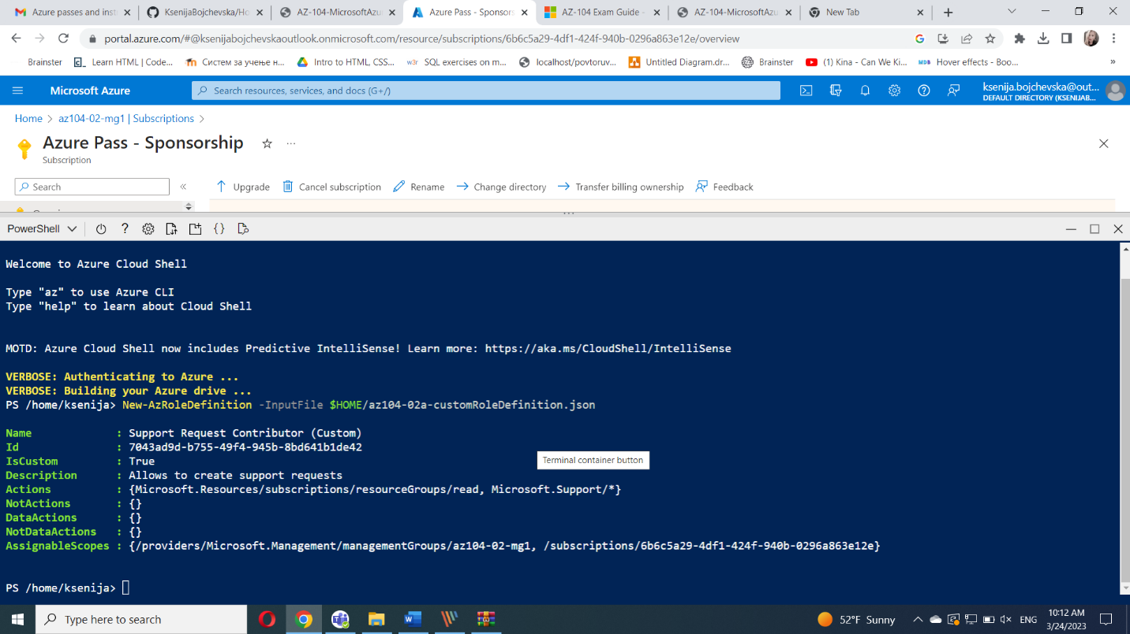

#### Task 3: Assign RBAC roles

In this task, you will create an Azure Active Directory user, assign the RBAC role you created in the previous task to that user, and verify that the user can perform the task specified in the RBAC role definition.

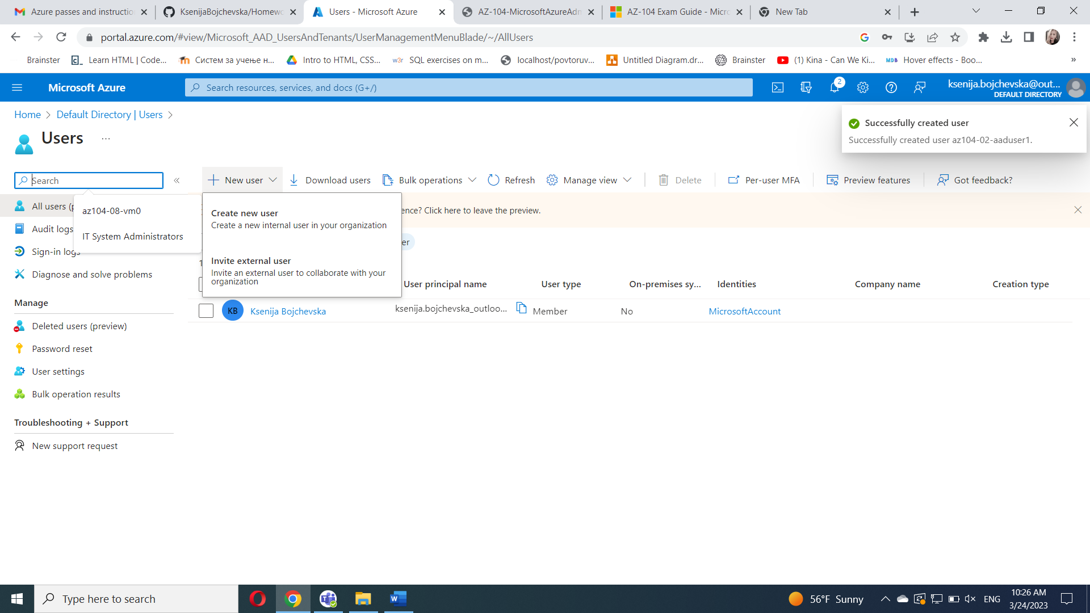

In the Azure portal, search for and select **Azure Active Directory**, on the Azure Active Directory blade, click **Users**, and then click **+ New user**.

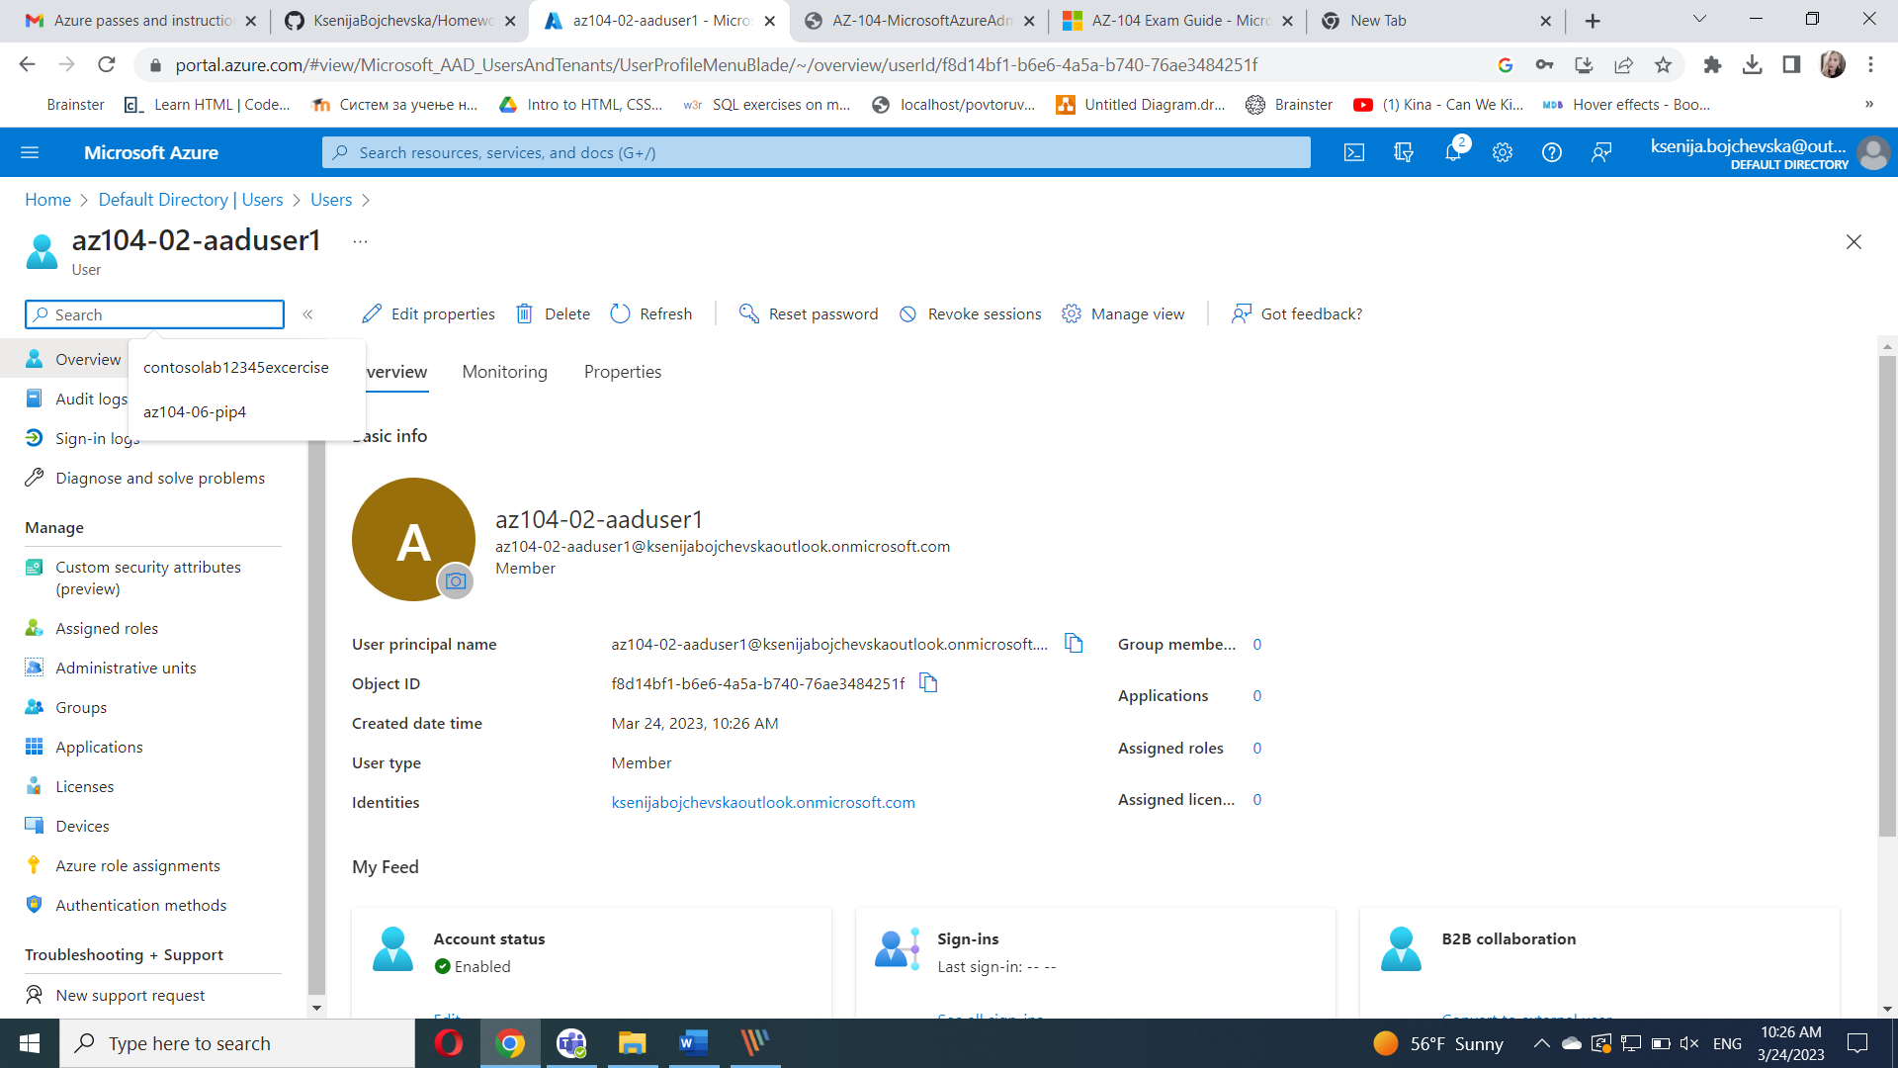

Create a new user with the following settings (leave others with their defaults):

In the Azure portal, navigate back to the **az104-02-mg1** management group and display its **details**.

Click **Access Control (IAM)**, click **+ Add** and then **Add role assignment**. On the **Role** tab, search for **Support Request Contributor (Custom)**.

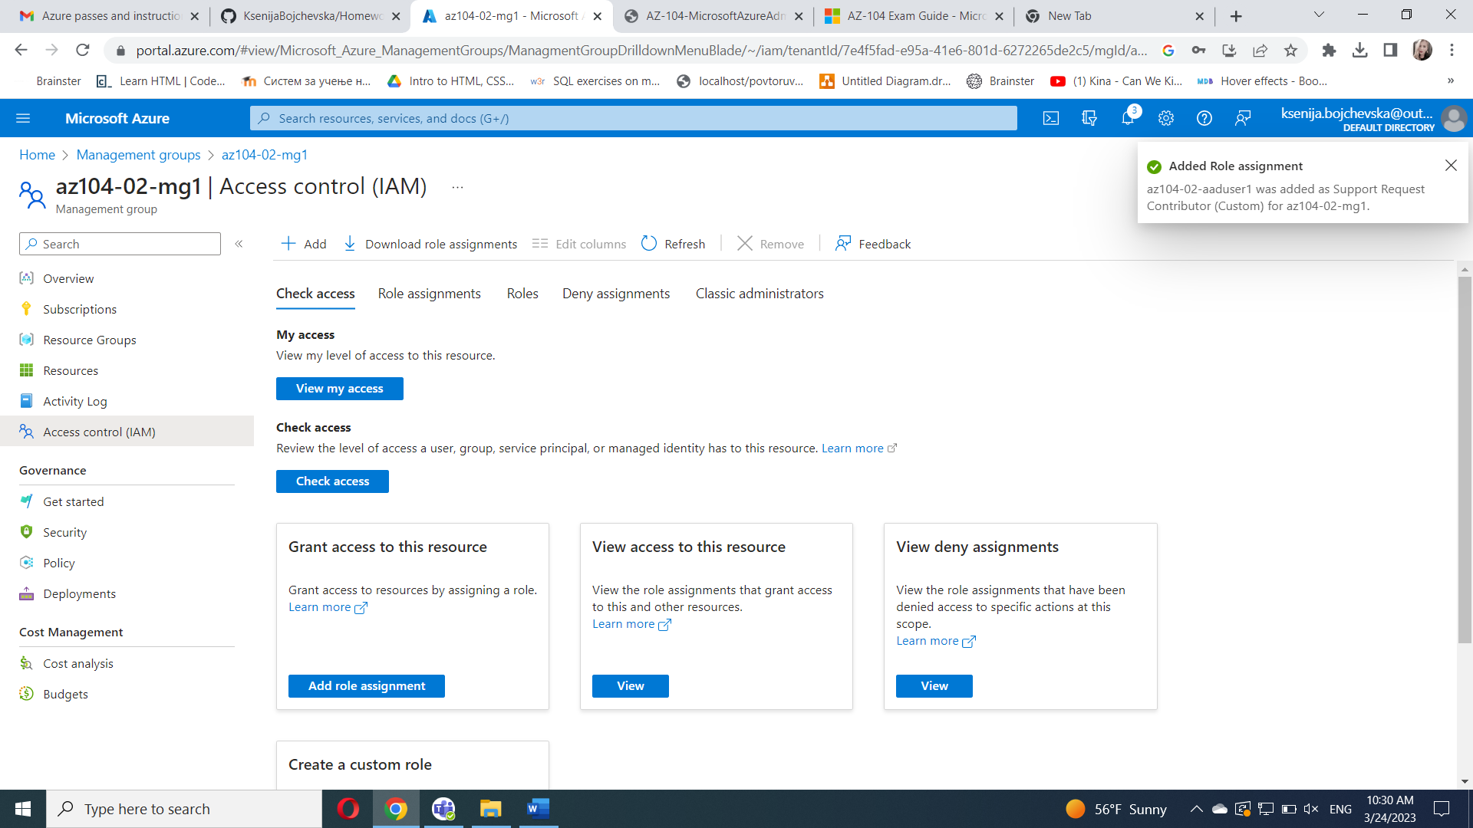Open an **InPrivate** browser window and sign in to the [Azure portal](https://portal.azure.com/) using the newly created user account. When prompted to update the password, change the password for the user.

In the **InPrivate** browser window, in the Azure portal, search and select **Resource groups** to verify that the az104-02-aaduser1 user can see all resource groups.

In the **InPrivate** browser window, in the Azure portal, search and select **All resources** to verify that the az104-02-aaduser1 user cannot see any resources.

In the **InPrivate** browser window, in the Azure portal, search and select **Help + support** and then click **+ Create a support request**.

In the **InPrivate** browser window, on the **Problem Description/Summary** tab of the **Help + support - New support request** blade, type **Service and subscription limits** in the Summary field and select the **Service and subscription limits (quotas)** issue type. Note that the subscription you are using in this lab is listed in the **Subscription** drop-down list.

Do not continue with creating the support request. Instead, sign out as the az104-02-aaduser1 user from the Azure portal and close the InPrivate browser window

